**NOVEL SOLID-STATE ELECTROLYTES**

**Introduction**

Conventional lithium-ion batteries (LIBs) rely on flammable organic liquid electrolytes due to their high ionic conductivity and excellent wetting of electrode surfaces. However, they often suffer from inadequate electrochemical and thermal stabilities giving rise to inherent safety risks and restrained operating temperatures. Non-flammable, solid-state electrolytes (SSEs) offer an escape from such problems offering potential for wider operating temperatures, higher energy-densities, and simplification in the cell design.

There are two general classes of SSEs for LIBs: polymer and inorganic solid electrolytes. A brief introduction to polymer electrolytes (PEs) is given in the **Polymer Syntheses** page. Therefore, the following section introduces inorganic solid electrolytes (ISEs).

ISEs, typically ceramics, provide greater electrochemical stability window and *t*Li+, enhanced thermal and chemical stabilities, and diminished flammability compared to PEs. However, due to low fracture toughness and ductility, ceramic electrolytes often show poor interfacial contact with electrodes and fail to meet requirements for fabricating thin and flexible films in practical applications. In addition, fabrication costs for ISEs are typically high, e.g. solid-state reactions, high temperature sintering and gas phase deposition, limiting bulk production for commercialization.

Common types of ISEs include garnet, perovskite, sodium super ion conductor (NASICON) and lithium super ion conductor (LISICON) crystalline electrolytes and glassy electrolytes such as lithium phosphorus oxynitride (LiPON). Representative structures for crystalline electrolytes are shown below.

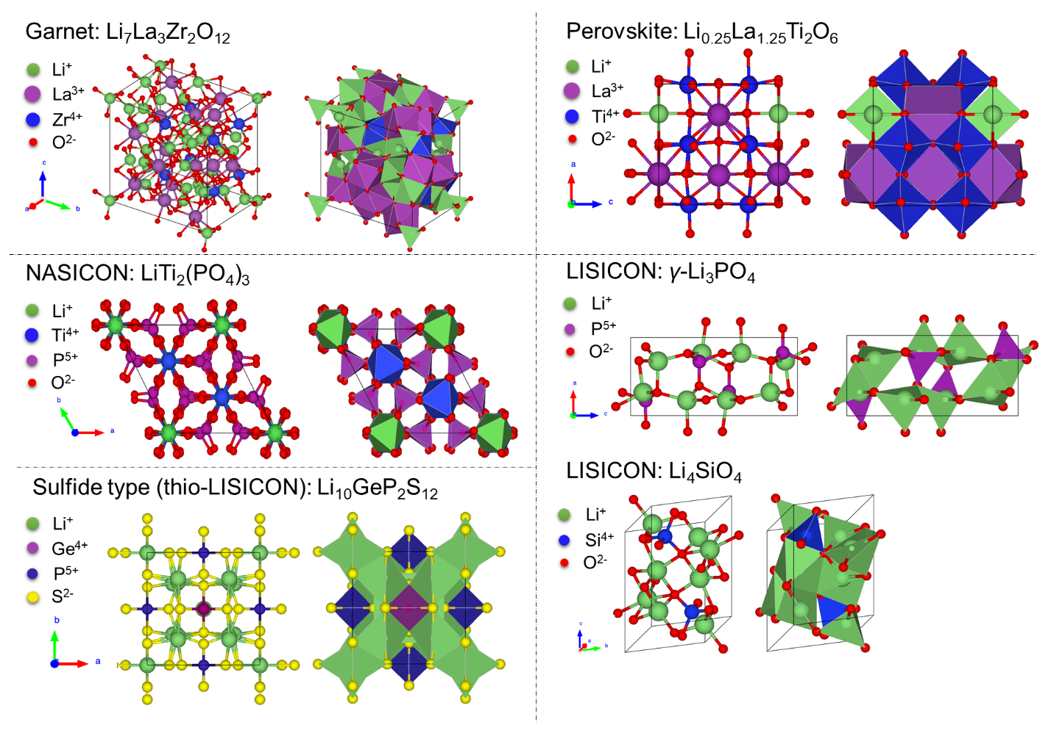

**LISICON and LiPON SSEs**

LISICON - γ-Li3PO4

LISICON-type SSEs are commonly used and studied. Typical LISICON-type compounds crystallize into structures similar to *γ*-Li3PO4 with an orthorhombic unit cell and *Pnma* space group, where all cations are tetrahedrally coordinated. The Li+ ions located in LiO4 tetrahedra diffuse between these tetrahedra and interstitial sites located in the PO4 network. Including Li3PO4, Li4SiO4, Li5AlO4, Li4±xSi1−xXxO4 (X = P, Al, or Ge), etc., they all belong to the LISICON family. In general, LISICON-type of SSEs have good chemical and electrochemical stability, but relatively low ionic conductivities (~10-6 S/cm) compared to other oxide solid electrolytes (e.g. Garnet-type SSEs show conductivities up to 10-4-10-3 S/cm).

LiPON glass - N-doped defective γ-Li3PO4

LiPON is a type of amorphous Li+ SSE. In principle, LiPON can be considered a Li+ defective *γ*-Li3PO4 with O partially substituted by N, with an example composition of Li2.94PO3.3N0.31. In general, the ionic conductivity of LiPON thin films increases significantly while the activation energy (*Ea*) for Li diffusion decreases with the atom percentage (at.%) of N incorporated in the structure. Studies1,2 found that N-doping forms PO3N as apical N (Na) and double-coordinated Nd bridge:

*see references:*

(1) Li, J.; Lai, W. Structure and Ionic Conduction Study on Li3PO4 and LiPON (Lithium Phosphorous Oxynitride) with the Density-Functional Tight-Binding (DFTB) Method. *Solid State Ion.* **2020**, *351*, 115329. https://doi.org/10.1016/j.ssi.2020.115329.

(2) Lacivita, V.; Artrith, N.; Ceder, G. Structural and Compositional Factors That Control the Li-Ion Conductivity in LiPON Electrolytes. *Chem. Mater.* **2018**, *30* (20), 7077–7090. https://doi.org/10.1021/acs.chemmater.8b02812.

The overall ionic conductivity is correlated with the amount of disorder and therefore amorphous LiPON exhibits higher conductivities than crystalline *γ*-Li3PO4, and Nd bridging increases the connectivity which enables amorphous LiPON to act as a single-ion conductor. In general, ionic conductivities for LiPON glasses are up to 10-6-10-5 S/cm at RT, which is still lower than what’s required (>10-4 S/cm) for all-solid-state-batteries (ASSBs). As a result, LiPON is typically applied as thin films (thickness < 5μm).

LiPON thin films are generally processed by gas phase deposition methods, such as RF magnetron sputtering, ion beam assisted deposition (IBAD), metalorganic-chemical vapor deposition (MOCVD), etc. Low deposition rates (typically <100 nm/min) and specialized apparatus required for gas phase depositions drive up the fabrication cost for large, homogeneous composition targets at commodity scales.

**Polymer Precursors derived Novel SSEs**

Different from traditional gas phase deposition methods, we explored polymer synthesis methods of preparing LiPON-like and LixSiON (based on N-doped LISICON-type SSEs) polymer precursors that exhibit ambient conductivities of ~10-5 S/cm, providing a novel, low cost, low temperature and scalable approach towards SSEs. Especially for LixSiON precursors which are derived from agricultural waste, rice hull ash, a green synthesis method has established.

Click to see more details for each project:

* LixPON and LixSiPON
* LixSiON
* Next Steps